Case 000157 - Trial Balance Report - STPIS



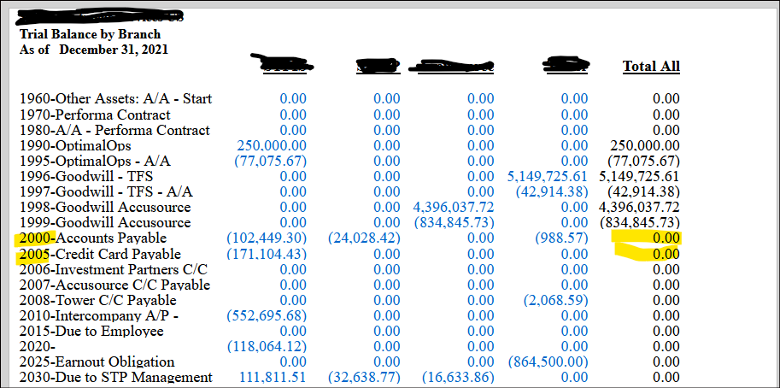

Each Column represents a separate Branch.

Throughout the report, the values in the first four columns are totaled in the 5th column **Total All,** except the lines populated by Liability or Revenue account ranges.

The Column Set Calculation is simply Columns B+C+D+E.

Do I need to add anything to have the calculation work for the ‘flipped’ rows?